What is cloud services and why to use it

Cloud services are infrastructure, platforms, or software that are hosted by third-party providers and made available to users through the internet.

Cloud services facilitate the flow of user data from front-end clients (e.g., users’ servers, tablets, desktops, laptops—anything on the users’ ends), through the internet, to the provider’s systems, and back. Cloud services promote the building of cloud-native applications and the flexibility of working in the cloud. Users can access cloud services with nothing more than a computer, operating system, and internet connectivity.

types of cloud services

Infrastructure as a Service (IaaS)
Infrastructure as a service provides the infrastructure that you need to manage SaaS tools, including servers, storage, and networking resources. The cloud provider would manage the storage servers and networking hardware and may also offer additional services like load balancing and firewalls.
Platform as a Service (PaaS)
Platform as a service is an environment in the cloud where developers can build and deploy apps. PaaS provides the database and operating system that is needed to develop cloud-based software. Developers can focus on their task, without needing to build and maintain the infrastructure that such software development processes normally require.
Software as a Service (SaaS)
A variety of services are available as Software as a Service, including file storage, backup, web-based email and project management tools. Using one of these applications, users can access, share, store and secure information in the cloud

Why to use it ?
Benefits:

1. High Speed – Quick Deployment
The ability to spin up new cloud computing instances in a matter of seconds reshaped the agility and speed of software development
2. Efficiency and Cost Reduction
By using cloud infrastructure, you don’t have to spend huge amounts of money on purchasing and maintaining equipment. This drastically reduces CAPEX costs and Total Cost of Ownership (TCO). You don’t have to invest in hardware, facilities, utilities, or building out a large data center to grow your business. You do not even need large IT teams to handle your cloud data center operations, as you can enjoy the expertise of your cloud provider’s staff.
Cloud also reduces costs related to downtime
3. Data Security
Cloud offers many advanced security features that guarantee that data is securely stored and handled. Features like granular permissions and access management via federated roles can restrict access to sensitive data only to the employees that need access to it, and by that reducing the attack surface for malicious actors
4. Scalibility
Cloud-based solutions are ideal for businesses with growing or fluctuating bandwidth demands. If your business demands increase, you can easily increase your cloud capacity without having to invest in physical infrastructure. This level of agility can give businesses using cloud computing a real advantage over competitors. This scalability minimizes the risks associated with in-house operational issues and maintenance
5. Disaster Recovery
Having previous versions of software stored in the cloud, and having production instances running on multiple cloud availability zones or regions allow for faster recovery from disasters: if your application is deployed on multiple locations and for some reason one region goes down – the traffic can automatically failover to the working regions without any interruptions to the end-users

Create account on AWS and GCP. Get familiar with UI

Account created on AWS
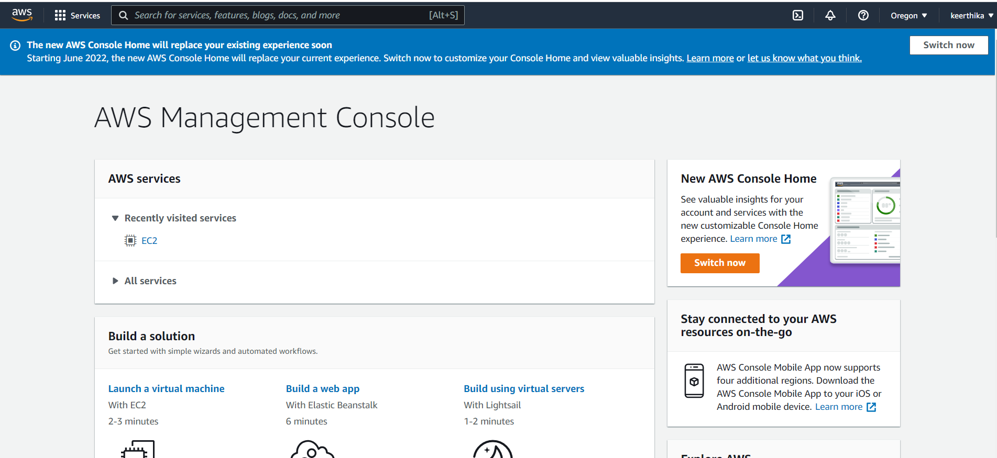

Account created on GCP

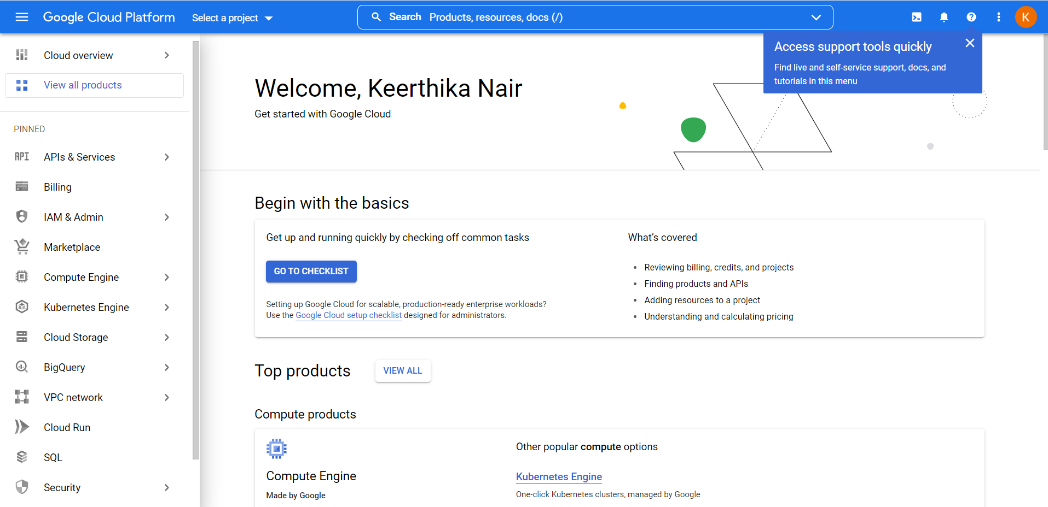
EC2
Amazon Elastic Compute Cloud (Amazon EC2) provides scalable computing capacity in the Amazon Web Services (AWS) Cloud. Using Amazon EC2 eliminates your need to invest in hardware up front, so you can develop and deploy applications faster. You can use Amazon EC2 to launch as many or as few virtual servers as you need, configure security and networking, and manage storage. Amazon EC2 enables you to scale up or down to handle changes in requirements or spikes in popularity, reducing your need to forecast traffic.
- Virtual computing environments, known as instances
-Preconfigured templates for your instances, known as Amazon Machine Images (AMIs)
- Secure login information for your instances using key pairs
- Storage volumes for temporary data that's deleted when you stop, hibernate, or terminate your instance, known as instance store volumes

Elastic IP addresses :
Static IPv4 addresses for dynamic cloud computing, known as Elastic IP addresses, by using EIP, you can easily mask the failure of the instance or s/w by rapidly remapping the address to another instance
An Elastic IP address is static; it does not change over time.
- To use an Elastic IP address, you first allocate one to your account, and then associate it with your instance or a network interface.
- When you associate an Elastic IP address with an instance, it is also associated with the instance's primary network interface. When you associate an Elastic IP address with a network interface that is attached to an instance, it is also associated with the instance.

Security Groups
- A firewall that enables you to specify the protocols, ports, and source IP ranges that can reach your instances (controlling the incoming and outgoing traffic )using security groups
Inbound rules control the incoming traffic to your instance, and outbound rules control the outgoing traffic from your instance. When you launch an instance, you can specify one or more security groups. If you don't specify a security group, Amazon EC2 uses the default security grou

- Empheral volume is ideal for temporary information which changes frequently such as buffer, cache

Elastic Block store
- Persistent storage volumes for your data using Amazon Elastic Block Store (Amazon EBS), known as Amazon EBS volumes
EBS behaves like a raw unformatted block devices, where you can mount these volumes on instances. You can create file systems on them and can use like harddrive.

Amazon EBS for data that must be quickly accessible and requires long-term persistence. EBS volumes are particularly well-suited for use as the primary storage for file systems, databases, or for any applications that require fine granular updates and access to raw, unformatted, block-level storage.

you can create EBS in a specific availability zone, to make it available outside AZ, snapshot is created.

Snapshots are incremental backups means that the blocks on the devices that have been changed after your most recent snapshot has been saved. This minimizes the time required to create the snapshot and saves on storage costs by not duplicating data. Each snapshot contains all of the information that is needed to restore your data (from the moment when the snapshot was taken) to a new EBS volume.
- Multiple physical locations for your resources, such as instances and Amazon EBS volumes, known as Regions and Availability Zones

-

ELB (Elastic Load balancing)

Elastic Load Balancing automatically distributes your incoming traffic across multiple targets, such as EC2 instances, containers, and IP addresses, in one or more Availability Zones. It monitors the health of its registered targets, and routes traffic only to the healthy targets.
Elastic Load Balancing scales your load balancer as your incoming traffic changes over time. It can automatically scale to the vast majority of workloads.

Auto-Scaling group
An Auto Scaling group contains a collection of Amazon EC2 instances that are treated as a logical grouping for the purposes of automatic scaling and management. An Auto Scaling group also enables you to use Amazon EC2 Auto Scaling features such as health check replacements and scaling policies. Both maintaining the number of instances in an Auto Scaling group and automatic scaling are the core functionality of the Amazon EC2 Auto Scaling service

An Auto Scaling group can launch On-Demand Instances, Spot Instances, or both. You can specify multiple purchase options for your Auto Scaling group only when you configure the group to use a launch template

Amazon Machine Images (AMI)

An Amazon Machine Image (AMI) is a supported and maintained image provided by AWS that provides the information required to launch an instance. You must specify an AMI when you launch an instance. You can launch multiple instances from a single AMI when you require multiple instances with the same configuration. You can use different AMIs to launch instances when you require instances with different configurations.
An AMI includes the following:
- One or more Amazon Elastic Block Store (Amazon EBS) snapshots, or, for instance-store-backed AMIs, a template for the root volume of the instance (for example, an operating system, an application server, and applications).
- Launch permissions that control which AWS accounts can use the AMI to launch instances.
- A block device mapping that specifies the volumes to attach to the instance when it's launched.
- Metadata, known as tags, that you can create and assign to your Amazon EC2 resources
- Virtual networks you can create that are logically isolated from the rest of the AWS Cloud, and that you can optionally connect to your own network, known as virtual private clouds (VPCs)

IAM

AWS Identity and Access Management (IAM) is a web service that helps you securely control access to AWS resources. You use IAM to control who is authenticated (signed in) and authorized (has permissions) to use resources.
- Shared access to your AWS account
- Granular permissions
- Secure access to AWS resources for applications that run on Amazon EC2
- Multi-factor authentication (MFA)
- Identity federation

S3
Amazon Simple Storage Service (Amazon S3) is an object storage service that offers industry-leading scalability, data availability, security, and performance. Customers of all sizes and industries can use Amazon S3 to store and protect any amount of data for a range of use cases, such as data lakes, websites, mobile applications, backup and restore, archive, enterprise applications, IoT devices, and big data analytics. Amazon S3 provides management features so that you can optimize, organize, and configure access to your data to meet your specific business, organizational, and compliance requirements.

How Amazon S3 works
Amazon S3 is an object storage service that stores data as objects within buckets. An object is a file and any metadata that describes the file. A bucket is a container for objects.
To store your data in Amazon S3, you first create a bucket and specify a bucket name and AWS Region. Then, you upload your data to that bucket as objects in Amazon S3. Each object has a key (or key name), which is the unique identifier for the object within the bucket.

Cloudwatch

Amazon CloudWatch monitors your Amazon Web Services (AWS) resources and the applications you run on AWS in real time. You can use CloudWatch to collect and track metrics, which are variables you can measure for your resources and applications.
The CloudWatch home page automatically displays metrics about every AWS service you use. You can additionally create custom dashboards to display metrics about your custom applications, and display custom collections of metrics that you choose.
You can create alarms that watch metrics and send notifications or automatically make changes to the resources you are monitoring when a threshold is breached. For example, you can monitor the CPU usage and disk reads and writes of your Amazon EC2 instances and then use that data to determine whether you should launch additional instances to handle increased load. You can also use this data to stop under-used instances to save money.

Monitors performance of the aws resourses

Cloudtrail
AWS CloudTrail is an AWS service that helps you enable governance, compliance, and operational and risk auditing of your AWS account. Actions taken by a user, role, or an AWS service are recorded as events in CloudTrail.

A detective that watches over the AWS account and environment. It provides info of what action was taken, who performed, when the action was taken, where was it taken

Route53

Amazon Route 53 is a highly available and scalable Domain Name System (DNS) web service. It routes end users to Internet applications by translating names to IP addresses.
It effectively connects user request to infrastructure running in AWS such as ec2, S3, ELB etc
You can use Route 53 to perform three main functions in any combination: domain registration, DNS routing, and health checking.

GCP

Compute Engine
Compute Engine is a computing and hosting service that lets you create and run virtual machines on Google infrastructure. Compute Engine offers scale, performance, and value that lets you easily launch large compute clusters on Google's infrastructure. There are no upfront investments, and you can run thousands of virtual CPUs on a system that offers quick, consistent performance.

Cloud storage
Cloud Storage allows world-wide storage and retrieval of any amount of data at any time. You can use Cloud Storage for a range of scenarios including serving website content, storing data for archival and disaster recovery, or distributing large data objects to users via direct download.

Local SSD

Compute Engine offers always-encrypted local solid-state drive (SSD) block storage for virtual machine (VM) instances.
Local SSDs are suitable only for temporary storage such as caches, processing space, or low value data. To store data that is not temporary or ephemeral in nature, use one of our durable storage options.

VPC
Virtual Private Cloud (VPC) provides networking functionality to Compute Engine virtual machine (VM) instances, Google Kubernetes Engine (GKE) clusters, and the App Engine flexible environment. VPC provides networking for your cloud-based resources and services that is global, scalable, and flexible.
Offers built-in Internal TCP/UDP Load Balancing and proxy systems for Internal HTTP(S) Load Balancing.
- Connects to on-premises networks using Cloud VPN tunnels and Cloud Interconnect attachments.
- Distributes traffic from Google Cloud external load balancers to backends.

